*Name: _________________________ Narrogin Senior High School*



**Unit 4 Modern History**

***SOURCE ANALYSIS TWO***

**The Changing European World Since 1945**

[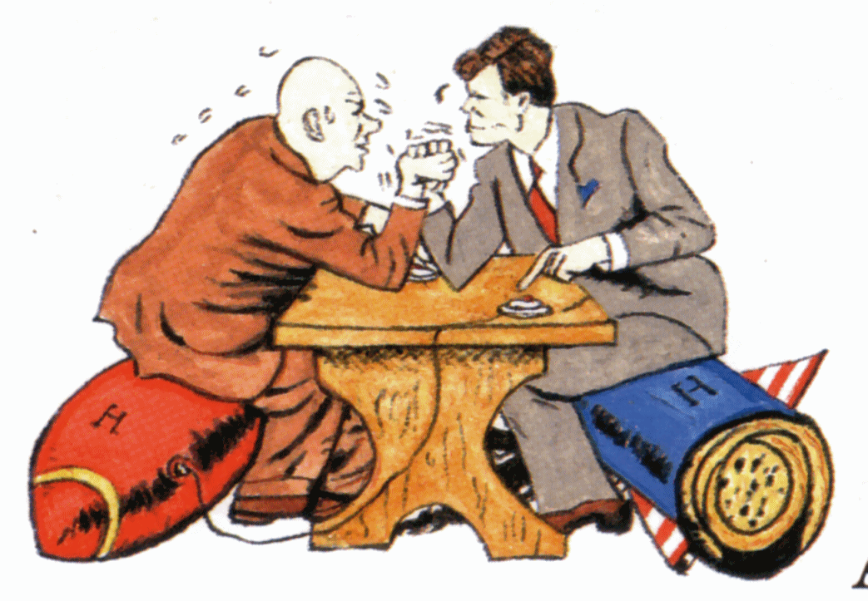](http://www.google.com.au/url?sa=i&rct=j&q=&esrc=s&source=images&cd=&cad=rja&uact=8&ved=0ahUKEwij__-ztObTAhVDFJQKHZXZBIcQjRwIBw&url=http://www.thelibertybeacon.com/do-we-really-need-to-re-start-the-cold-war/cold-war/&psig=AFQjCNECyeA0ZP1CH5fAxGj_7_KI0fwKzw&ust=1494542926002153)

**Marks out of 25:**

**Weighting - 5 %**

**SECTION TWO: SOURCE ANALYSIS SET 1, Unit 4**

This section has ONE question made up of **FIVE (5)** parts. Attempt **ALL** parts. Write your answers in the spaces provided.

* The marks allocation for this section is 25 marks.
* Allow approximately 45 minutes for this section.

Indicate below the document set from the **Document Booklet** you will use to respond to this

question.

Set 1: □ The changing European world since 1945

Set 2: □ Australia’s engagement with Asia

Set 3: □ The struggle for peace in the Middle East

**Question 1**

1. Explain the historical context of **Source 1**. Include the relevant events, people and ideas depicted or represented in the source. *(3 marks)*

**See next page**

**(b)** Compare and contrast the purpose of **Sources 1** and **2.** (6 marks)

**See next page**

**(c)** Identify and explain the message/s of **Source 3**. (3 marks)

**See next page**

1. Identify how and discuss why **Source 3** and **4** are contestable. (6 marks)

**See next page**

1. Using your knowledge of the whole period of study, evaluate the importance of the themes, ideas and/or events represented in the four sources.

(7 marks)

__________________________________________________________________

__________________

________________________________________

**END OF SECTION**

Question number:

Question number:

Modern History – ATAR Year 12 - Documents

Task 9– Unit 4 The Modern World since 1945; **The changing European world since 1945**

**Source 1:**

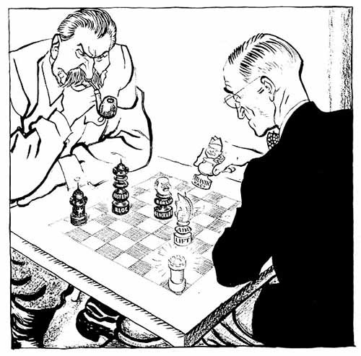

‘Stalin and Truman Play Chess.’ British cartoonist Illingworth published in the Daily Mail, 14th February 1949.

Stalin’s pieces labelled Eastern Bloc, Berlin Blockade and Berlin Airlift. Truman’s pieces labelled Atlantic Pact and Air Lift

**Source 2:**

Kelly, B et al. 2015. *The Changing World Order*. South Melbourne; Cenage Learning Australia.

Historians accept that Stalin did not want to provoke a war by blockading Berlin. He perhaps felt it inevitable the West and East would be permanently divided, and it is likely he wanted the West to give up Berlin. But Berlin was too important for the Americans to let go. Although the city was of no practical or strategic significance to them, it was of enormous symbolic value. To let Berlin go would mean accepting the principle of a Soviet sphere of influence in the East, and the Americans were not willing to move on this point. The loss of Berlin would be a triumph of communism over capitalism.

**Source 3:**

*An address to the American people by President Kennedy, 25th July 1961. The Cold War in Berlin* taken from John F. Kennedy Presidential Library and Museum website: <http://www.jfklibrary.org/JFK/JFK-in-History/The-Cold-War-in-Berlin.aspx>

"So long as the communists insist that they are preparing to end by themselves unilaterally our rights in West Berlin and our commitments to its people, we must be prepared to defend those rights and those commitments. We will at times be ready to talk, if talk will help. But we must also be ready to resist with force, if force is used upon us. Either alone would fail. Together, they can serve the cause of freedom and peace."

**Source 4:**

*Contrary to the previous view of the cold war, Harrison argued, the East Germans did exert various forms of power over the Soviets. Khrushchev was deeply committed to the triumph of socialism over capitalism in Germany, remarking that, if socialism did not win in East Germany, then the Soviets would not win.*

*The East Germans learned from this that they could parlay the weakness of their regime into strength in bargaining with the Soviets. East German motivation to solve the problem of their citizens fleeing to capitalist West Berlin and West Germany and their willingness and capability to act unilaterally were very important in the crisis.*

*Harrison described Khrushchev's November 1958 ultimatum to the Western powers which set a six month deadline and demanded the signing of a peace treaty (still not concluded since World War II ended), either with a united Germany or with the two existing Germanies, and that West Berlin be transformed into a demilitarized free city. If these demands were not met, the Soviets would sign a separate peace treaty with East Germany and turn over control over the access routes between West Germany and West Berlin to East Germany.*

**Koehn, J. July 2011. *East Germans Pressured Soviets to Build Berlin Wall.* From Woodrow Wilson International Centre for Scholars.**